Storyboarding

Storyboards are graphic representations of exactly what would appear in each shot of a film’s adaptation of a text. Although a storyboard has no dialogue balloons, it is somewhat like a comic strip. Directors use storyboards in order to outline the entire movie they’re planning to shoot. It’s the stage of pre-production that gets them from the written script to the motion picture.

Storyboarding Activity: Try to create at least three “shots” that you could envision in your trailer. You can continue storyboarding more shots on a larger sheet of paper, or use the empty chart on the back to map out a number of shots in your trailer.

Shot | What did you want to demonstrate? | What lines/moments from your essay inspired this?
Shot 1  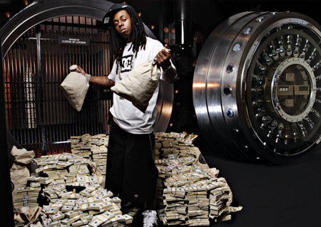 | The current norms around hip-hop, and how artist feed to it to gain commercial success. | Where I am describing the cultural norms that exists, and how different labels fort time periods exist.
Shot 2  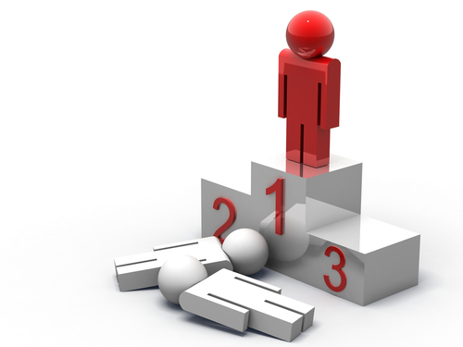 | That being different puts you in the number one spot. This proves my main point that going against the norms to create new ones is better than conforming to them to gain success. | I make the arguments that lil kim, gaga, and minaj break out breaking cultural norms, and creating new ones.
Shot 3   | The cookie cutter artist, a metaphor for how artist fit into a mold | Further reinforces the first shot and provides a clever metaphor for people to relate to.

What music or sound effects would you use in these shots? Why?

I am your leader by Nicki Minaj. It’s a good tune that sets the tone and my argument is covering how Nicki Minaj is a leader in breaking cultural norms.

